"Christ Is Risen" by Matt Maher in D

ORDER OF THE SONG:

I – A1 – B – I - A2 – B – C – B - I

I(=Intro)
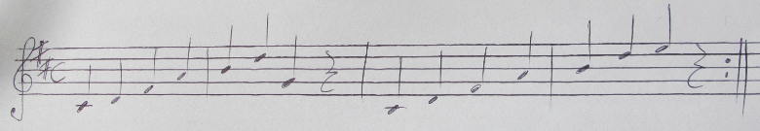
A1(=Verse 1)
A2(=verse 2)
Be- neath the weight of all our sin
You bow to none but heavens will
No scheme of hell, no scoffer's crown
No burden great can hold you down
In strength you reign
Forever let your church proclaim:
D
Let no one caught in sin remain
G
In- side the lie of inward shame
D
We fix our eyes upon the cross
G A
And run to him who showed great love
D/F# G A
And bled for us
D/F# G A
Freely you bled, for us
B(=Chorus)
D
Christ is risen from the dead
Trampling over death by death
Christ is risen from the dead
We are one with him again
Come awake, come awake!
Come and rise up from the grave!
G
Come a- wake, come awake!
bm A
Come and rise up from the grave!

C(=bridge)
D/F# G bm A
Oh death! Where is your sting?
Oh hell! Where is your victory?
Oh Church! Come stand in the light!
Our God is not dead, he's alive! he's alive!
Oh death! Where is your sting?
D/F# G bm A
Oh hell! Where is your victory?
D/F# G bm A
Oh Church! Come stand in the light!
D/F# G bm A
The glory of God has de- feated the night

